Course Name: | Competitive Programming Laboratory (216U01L401) | Semester: | IV
Date of Performance: | __/__/ _____ | DIV/ Batch No: | C3
Student Name: | Om Satish Thanage | Roll No: | 16010123217

Experiment No: 6
Title: To use string algorithms to solve competitive programming problems.
- Given an array of strings strs, group the anagrams together. You can return the answer in any order.

- Example 1:
- Input: strs = ["eat","tea","tan","ate","nat","bat"]
Output: [["bat"],["nat","tan"],["ate","eat","tea"]]
Explanation:
  - There is no string in strs that can be rearranged to form "bat".
  - The strings "nat" and "tan" are anagrams as they can be rearranged to form each other.
  - The strings "ate", "eat", and "tea" are anagrams as they can be rearranged to form each other.
- Example 2:
Input: strs = [""]
Output: [[""]]
Example 3:
Input: strs = ["a"]
Output: [["a"]]
- 0
- Handed in
- 22
- Assigned
- View instructions
- Exp-05 Dynamic Prog

Aim and Objective of the Experiment:
- Understand the concepts of string algorithm.
- Apply the concepts to solve the problem.
- Implement the solution to given problem statement.
- Create test cases for testing the solution.
- Analyze the result for efficiency of the solution.

COs to be achieved:
CO4: Apply geometry, game theory, and string algorithms in competitive programming.

Books/ Journals/ Websites referred:
- Students should write

Theory:
Students should write

Problem statement
To use string algorithms to solve competitive programming problems.
- Given an array of strings strs, group the anagrams together. You can return the answer in any order.

- Example 1:
- Input: strs = ["eat","tea","tan","ate","nat","bat"]
Output: [["bat"],["nat","tan"],["ate","eat","tea"]]
Explanation:
  - There is no string in strs that can be rearranged to form "bat".
  - The strings "nat" and "tan" are anagrams as they can be rearranged to form each other.
  - The strings "ate", "eat", and "tea" are anagrams as they can be rearranged to form each other.
- Example 2:
Input: strs = [""]
Output: [[""]]
Example 3:
Input: strs = ["a"]
Output: [["a"]]
- 0

Code :
from collections import defaultdict
strs = list(input().strip().split())
group = defaultdict(list)
for s in strs:
temp = "".join(sorted(s))
group[temp].append(s)
res = list(group.values())
print(res)

Output:
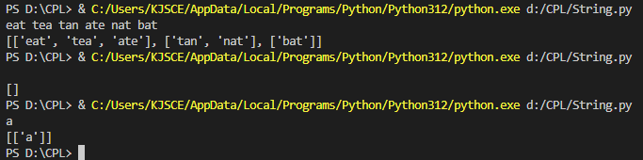

Post Lab Subjective/Objective type Questions:
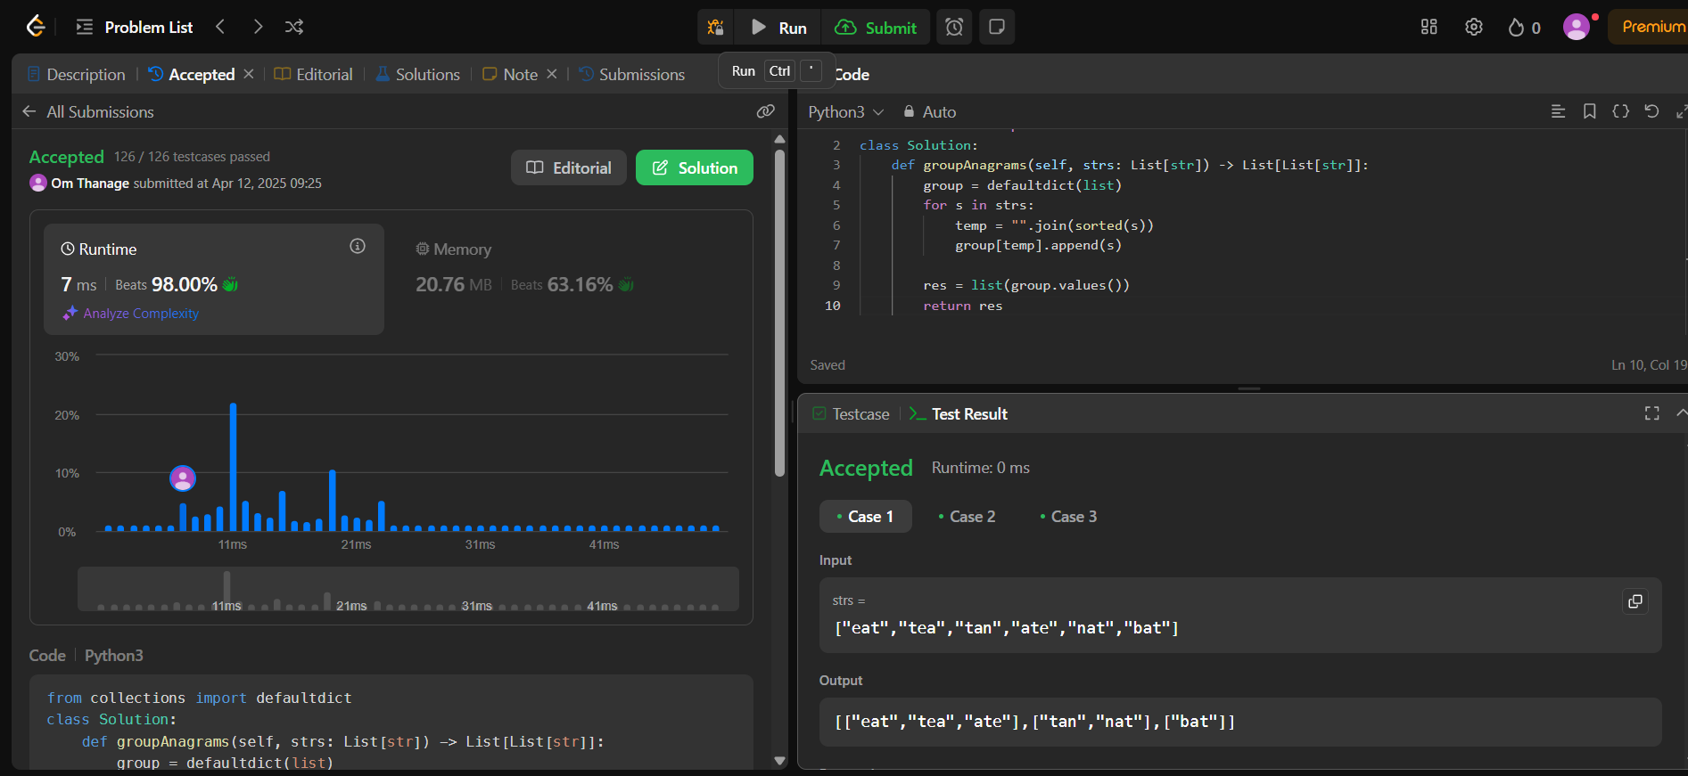

Conclusion:
In this experiment have manipulated the string to find the anagram of the string and pair then together

